10. Scenario: You are working on a data visualization project and need to create basic plots using Matplotlib. You have a dataset containing the monthly sales data for a company, including the month and corresponding sales values. Your task is to develop a Python program that generates line plots and bar plots to visualize the sales data.
Question:
- How would you develop a Python program to create a line plot of the monthly sales data?
- 2 How would you develop a Python program to create a bar plot of the monthly sales data?
Code:
import matplotlib.pyplot as plt
m = ['Jan','Feb','Mar','Apr','May']
s = [100,150,120,180,200]
plt.plot(m, s)
plt.show()
plt.bar(m, s)
plt.show()
Output:
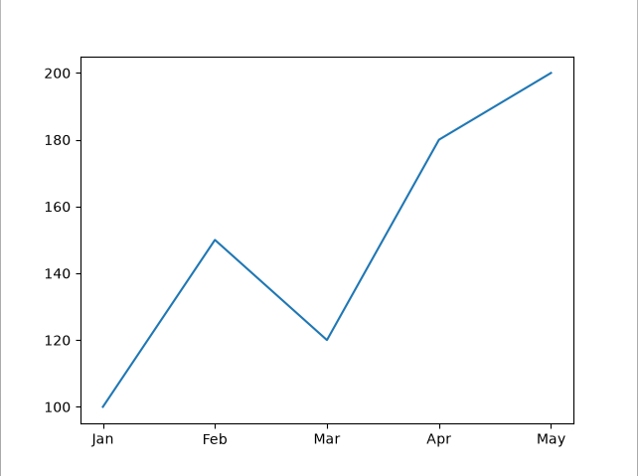
11. Scenario : You are a data scientist working for a company that sells products online. You have been tasked with creating a simple plot to show the sales of a product over time.
Question:
1. Write code to create a simple line plot in Python using Matplotlib to predict sales happened in a month?
2. Write code to create a scatter plot in Python using Matplotlib to predict sales happened in a month?
3. Develop a Python program to create a bar plot of the monthly sales data.
Code:
import matplotlib.pyplot as plt
m = ['Jan','Feb','Mar','Apr','May']
s = [100,150,120,180,200]
plt.plot(m, s)
plt.show()
plt.scatter(m, s)
plt.show()
plt.bar(m, s)
plt.show()
output:
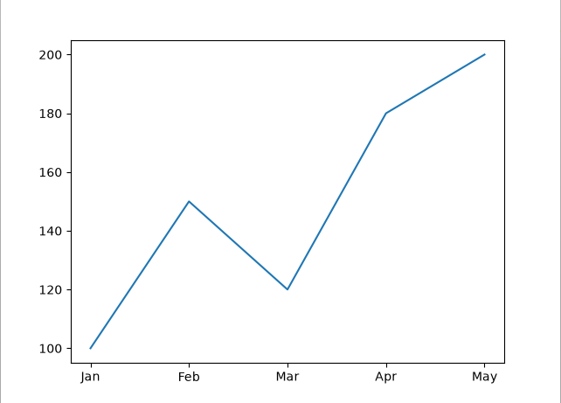12. Scenario: You are working on a data analysis project that involves analyzing the monthly temperature and rainfall data for a city. You have a dataset containing the monthly temperature and rainfall values for each month of a year. Your task is to develop a Python program that generates line plots and scatter plots to visualize the temperature and rainfall data.
Question:
1. Develop a Python program to create a line plot of the monthly temperature data.
2: Develop a Python program to create a scatter plot of the monthly rainfall data.
Code:
import matplotlib.pyplot as plt
m = ['Jan','Feb','Mar','Apr','May']
t = [25,27,30,32,31]
r = [20,30,45,60,50]
plt.plot(m, t)
plt.show()
plt.scatter(m, r)
plt.show()
output:
